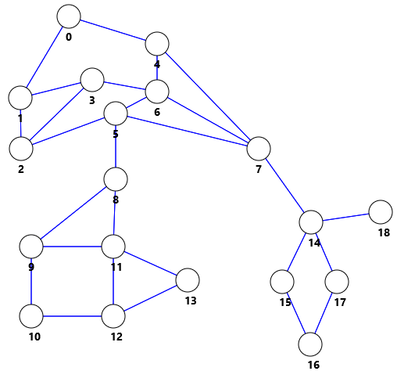

|  |  |
| --- | --- |
| adj[] |  |
| 0 | 4 1 |
| 1 | 3 2 0 |
| 2 | 5 3 1 |
| 3 | 6 2 1 |
| 4 | 7 6 0 |
| 5 | 8 7 6 2 |
| 6 | 7 5 4 3 |
| 7 | 14 5 6 4 |
| 8 | 11 9 5 |
| 9 | 11 10 8 |
| 10 | 12 9 |
| 11 | 13 12 9 8 |
| 12 | 13 11 10 |
| 13 | 12 11 |
| 14 | 18 17 15 7 |
| 15 | 16 14 |
| 16 | 17 15 |
| 17 | 14 16 |
| 18 | 14 |

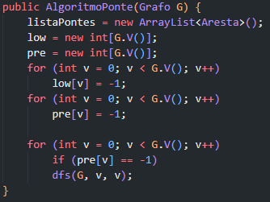

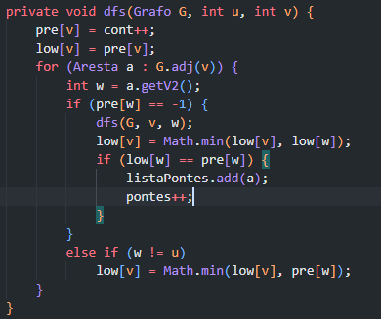

|  |  |  |
| --- | --- | --- |
| V | Pre[] | Low[] |
| 0 | 0 | 0 |
| 1 | 18 | 0 |
| 2 | 17 | 0 |
| 3 | 16 | 0 |
| 4 | 1 | 0 |
| 5 | 8 | 0 |
| 6 | 15 | 0 |
| 7 | 2 | 0 |
| 8 | 9 | 9 |
| 9 | 14 | 9 |
| 10 | 13 | 9 |
| 11 | 10 | 9 |
| 12 | 12 | 9 |
| 13 | 11 | 9 |
| 14 | 3 | 3 |
| 15 | 7 | 3 |
| 16 | 6 | 3 |
| 17 | 5 | 3 |
| 18 | 4 | 4 |

|  |
| --- |
| Fila (Início) |
| ~~dfs(G, 2, 1)~~ |
| ~~dfs(G, 3, 2)~~ |
| ~~dfs(G, 6, 3)~~ |
| ~~dfs(G, 5, 6)~~ |
| ~~dfs(G, 10, 9)~~ |
| ~~dfs(G, 12, 10)~~ |
| ~~dfs(G, 13, 12)~~ |
| ~~dfs(G, 11, 13)~~ |
| ~~dfs(G, 8, 11)~~ |
| ~~dfs(G, 5, 8)~~ |
| ~~dfs(G, 7, 5)~~ |
| ~~dfs(G, 16, 15)~~ |
| ~~dfs(G, 17, 16)~~ |
| ~~dfs(G, 14, 17)~~ |
| ~~dfs(G, 14, 18)~~ |
| ~~dfs(G, 7, 14)~~ |
| ~~dfs(G, 4, 7)~~ |
| dfs(G, 0, 4) |
| dfs(G, 0, 0) |

|  |
| --- |
| ListaPontes |
| 14 | 18 |
| 7 | 14 |
| 5 | 8 |